

**Test 6 2015**

**Organic Chemistry**

**Question/Answer Booklet**

**CHEMISTRY**

**ATAR Unit 1 and 2**

|  |  |
| --- | --- |
| **Student Name:** |  |
| **Teacher** |  |

|  |  |
| --- | --- |
| **Section** | **Mark** |
| One | /8 |
| Two | /42 |
| Total | /50 |
| % | |

**Time allowed for this paper**

Working time for paper: 50 minutes

**Material required/recommended for this paper**

***To be provided by the supervisor***

This Question/Answer booklet

Multiple-choice Answer sheet

Chemistry Data sheet

***To be provided by the candidate***

Standard items: pens (blue/black preferred), pencils (including coloured), sharpener, correction fluid/tape, eraser, ruler, highlighters

Special items: non-programmable calculators approved for use in the WACE examinations

**Important note to candidates**

No other items may be taken into the examination room. It is **your** responsibility to ensure that you do not have any unauthorised notes or other items of a non-personal nature in the examination room. If you have any unauthorised material with you, hand it to the supervisor **before** reading any further.

**Section One: Multiple-choice (8 marks)**

This section has **8** questions. Answer **all** questions on the grid below

Each question has only one correct answer. Select your answer by placing a cross in the box on the answering grid below. Attempt all questions.

**Please mark the correct answer with an ‘x’ on the answer grid below.**

|  |  |  |  |  |
| --- | --- | --- | --- | --- |
| **Question** |  |  |  |  |
| **1** | **A** | B | C | D |
| **2** | A | B | C | D |
| **3** | A | B | C | D |
| **4** | A | B | C | D |
| **5** | A | B | C | D |
| **6** | A |  | C | D |
| **7** |  | B | C | D |
| **8** | A | B |  | D |

1. Which of the following obeys the IUPAC system of naming?
2. 1,2-dibromobut-2-ene
3. acetic acid
4. cis-1,1-dichloroethene
5. sodium bicarbonate
6. Which of the following formulae represents a molecule that is saturated?
7. CH2CHCH2CH3
8. H2CC(CH3)2
9. CH3CH2CH3
10. CH3CCCH3
11. Which of the following is the correct equation for the complete combustion of

Hex-1-ene?

1. C6H10  + 12O2 → 7CO2 + 10H2O
2. C6H12  + 12O2 → 6CO2 + 6H2O
3. C6H12  + 9O2 → 6CO2 + 6H2O
4. C6H12  + 3O2 → 6C + 6H2O
5. Which of the following has the highest boiling point?

a) C5H12

b) C6H14

c) C7H16

d) C8H18

1. When an aqueous solution of iodine is added to cyclohexane in the presence of

ultraviolet light which one of the following is observed?

1. The brown solution fades.
2. A purple solid appears.
3. A yellow precipitate is formed.
4. A colourless gas is evolved.
5. A commonly-used test in organic chemistry is to shake a sample of a 8. Which one of the following sets of formulae contains only **one** saturated hydrocarbon?

(a) C2H6, C3H6, C4H8

(b) C3H6, C4H8, C6H12

(c) C2H6, C3H6, C8H18

(d) CH4, C2H6, C6H14

7. A commonly-used test in organic chemistry is to shake a sample of a compound with bromine water and observe the colour change, if any, of the bromine water. Which one of the following compounds would cause the colour of bromine water to fade in such a test?

a) benzene

b) ethene

c) ethane

d) cyclopentane

8. Which one of the following is **not** a reason for carbon to be able to form large numbers of compounds?

(a) The ability of carbon atoms to form four covalent bonds.

(b) The ability of carbon atoms to bond to each other in covalent network structures.

(c) The ability of carbon atoms to form multiple (double and triple) covalent bonds.

(d) The ability of carbon atoms to bond with each other to form long stable chains.

**END OF SECTION ONE**

Section 2: Extended Answers (42 MARKS)

Question 1 (9 marks)

The molecular formulae of two hydrocarbons M and N are given.

**M** = C4H10

**N**  = C4H8

a. **M** reacts with chlorine to form C4H9Cl. Write a balanced chemical equation for the reaction of chlorine with **M**. Be sure to include any conditions or catalysts. (2 marks)

C4H10 + Cl2 UV light→ C4H9Cl + HCl

Name this type of reaction: substitution (1 mark)

b. Draw and name a position isomer of N. (2 marks)

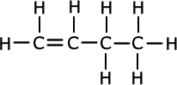

Name: **_____but-1-ene_________________**

c. Complete the boxes to show the structural formula and name for each of the products formed in the following addition reactions. (4 marks)



Name:2,3-dichlorobutane Name: butane

1 mark for each name and structure

Question 2 (11 marks)

The following questions are on benzene:

The chemist Kekule in the 19th century suggested the following structure for benzene:



a. Use the following data to explain what is wrong with the Kekule model and describe the generally accepted structure of benzene. (4 marks)





**breaking bond of the double bonds by addition reactions (1)**

**release -120 kJ, therefore three bonds would release 360 kJ not 208 kJ (1)**

**covalent bonding: each C atom single bonded to 2 others and 1 hydrogen (1)**

**four electrons delocalized between two resonance structures (1)**

b. Using the differences in structure between Benzene and the alkenes, explain why the reactions of benzene are different from the reactions of alkenes. (4 marks)

benzene – saturated – no double bonds (1)

alkenes – unsaturated -double bonds (1)

in alkenes double bond broken, add to C atoms either side (1)

in benzene – only sub rxns (1)

c. Write an overall equation with structural diagrams for the conversion of benzene into bromobenzene and state the conditions typically required in this conversion to occur. (3 marks)

C6H6 + Br2 → C6H5Br + HBr

Correct reactants and products (1)

Correct conditions (UV and/or heat) (1)

Structural diagrams (1)

Question 3 (2 marks)

Complete the following table by writing the IUPAC name of the compound or drawing the structure as appropriate. Show **all** hydrogen atoms for structures you draw. (FIRST AND LAST)

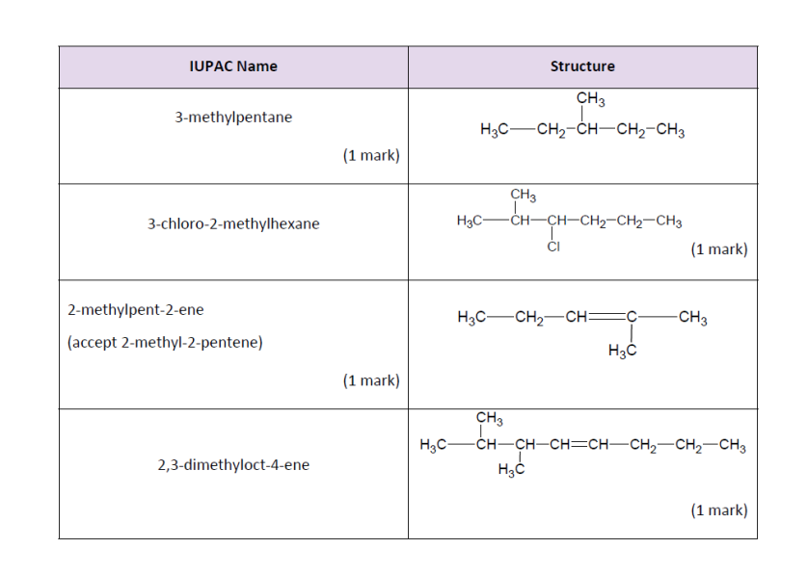

Question 4 (6 marks)

It is possible for straight chain and branched alkanes with the molecular formula C5H12 to exist. Draw and name the structural formulae of the 3 possible alkanes with this molecular formula. Show **all** hydrogen atoms in your structures. 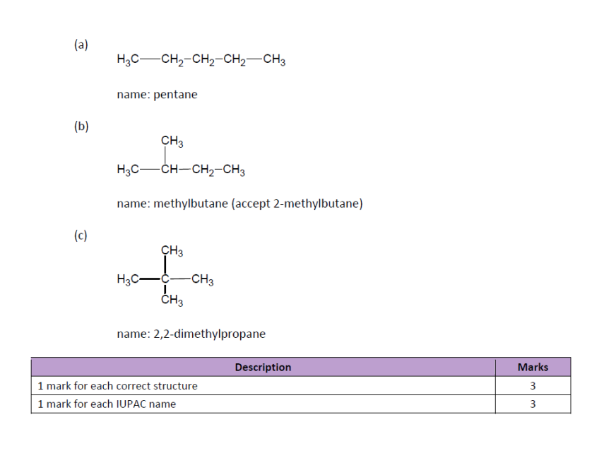

Question 5 (12 marks)

Propane gas is used in gas cylinders for barbeques. The equation for combustion of propane is shown below with its enthalpy change.

C3H8(g) + 5 O2(g) 3 CO2(g) + 4 H2O(g) + 2202 kJ

a. Sketch an energy diagram to demonstrate this reaction. Label the diagram to show the Energy of Activation and the Enthalpy Change (3marks)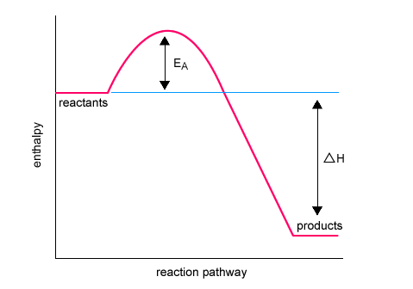

(1) hump and reactants above (1)

(1) Ea and delta H (1 mark) need both for mark (no ½ marks)

b. In terms of bonds broken and bonds made, explain why this is an exothermic reaction. (2 marks)

**Energy needed to break bonds is less than energy released when forming bonds (1)**

**Therefore net release of energy (1)**

c. If a gas cylinder contains 45.0 kg of propane, how much energy (in kilojoules) can be produced by the combustion of the gas? (4 marks)

|  |  |
| --- | --- |
| **Description** | **Marks** |
| M(C3H8) = 44.094 g mol–1 | 1 |
| m(C3H8) = 45.0 kg = 45000 g | 1 |
| 45000 3  n(C3H8) =  1.0205 10 mol  44.094 | 1 |
| Energy = 2202 × 1.0205 × 103 = 2.25 × 106 kJ | 1 |

d. We can use bond energies to calculate the energy change for the reaction between hydrogen and oxygen. (2 marks)

2H2 + O2 🡪 2H2O

|  |  |
| --- | --- |
| Bond | Bond energy in kJ |
| H – H | 436 |
| O – H | 464 |
| O = O | 498 |

i. Calculate the total bond energy of the reactants and products

_______________________________________________________________________________________________________________________________________________________________________________________________

Total bond energy of reactants = **.........+ 1370.................** kJ (1)

Total bond energy of products = **..........- 1856..................** kJ (1)

(need – sign for mark)

**END OF TEST**